Lab6 Homework ITCSIU22266
Exercise 5:
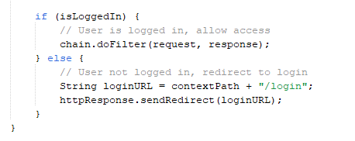
AuthFilter.java navigate user to login page if they haven’t logged in yet or the session expired.
For example, user session has expired, then navigate to login page, else, gain access to the webpage
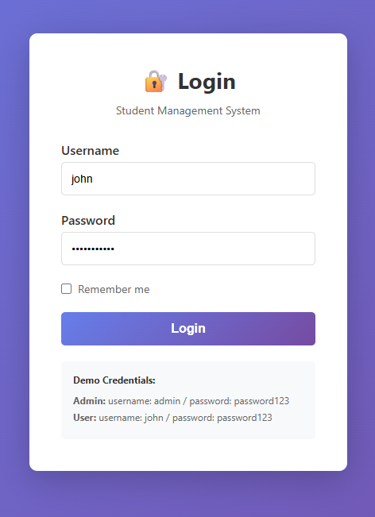
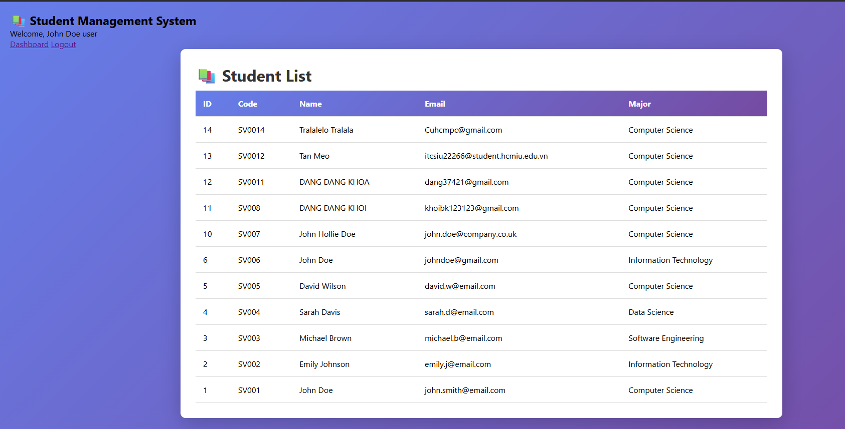
Exercise 6:
Login as admin, will navigate to admin dashboard
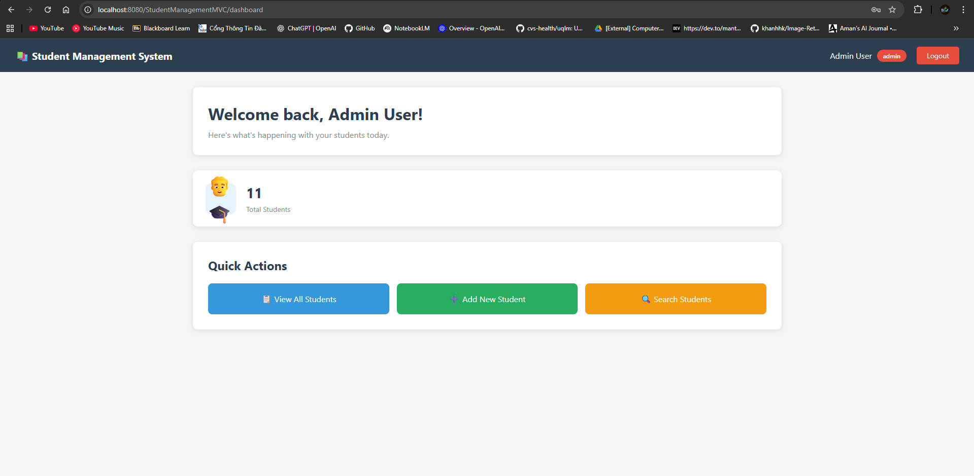
Admin have permission to edit/delete student,
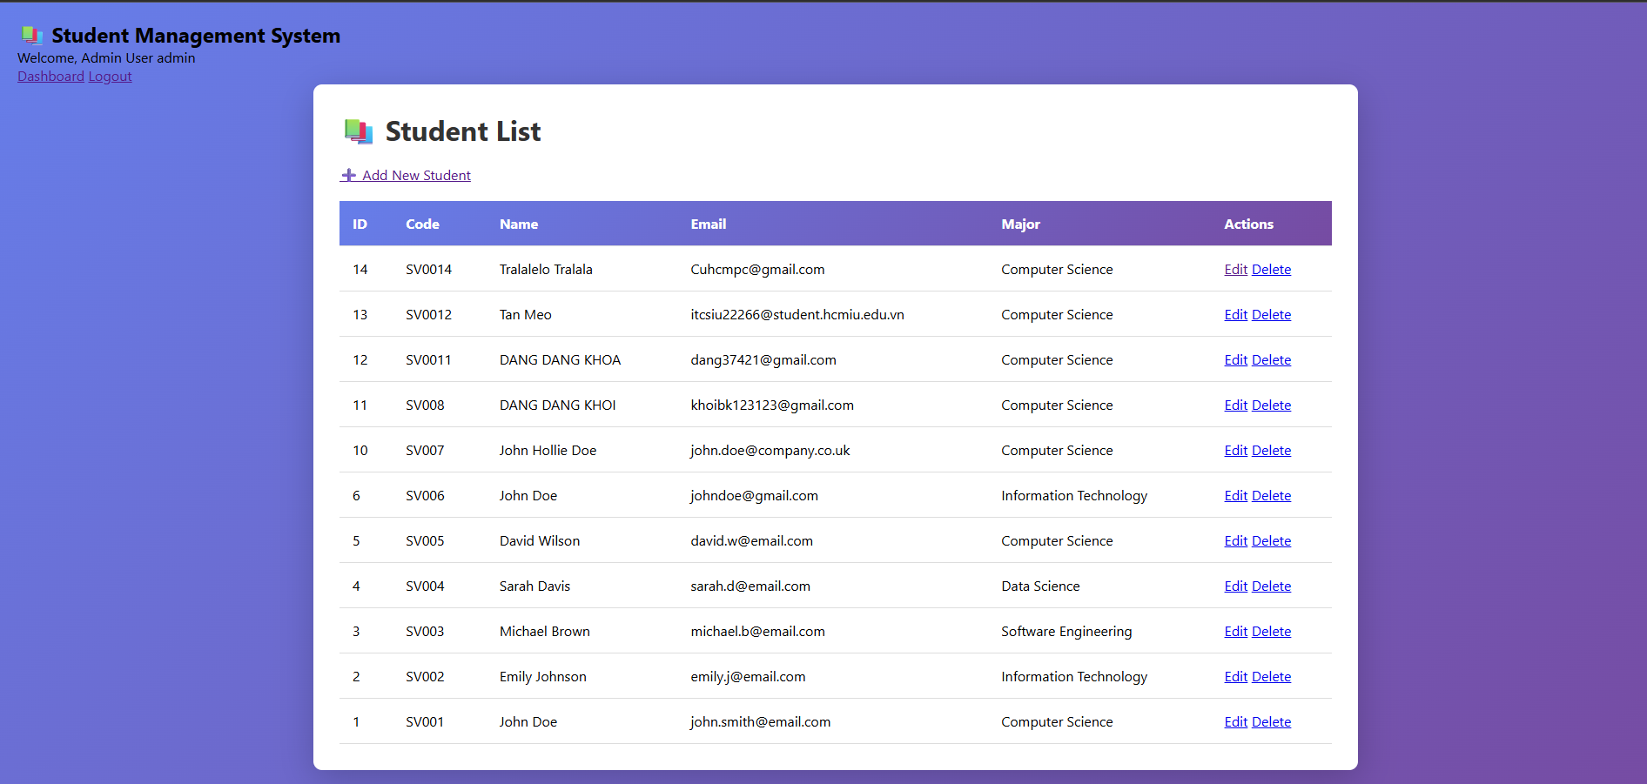
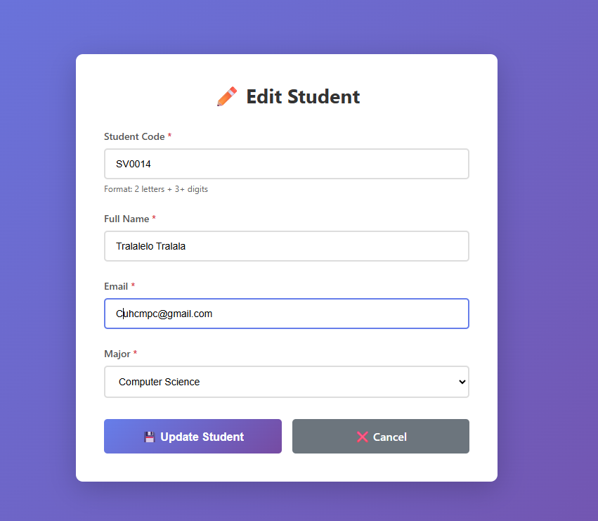
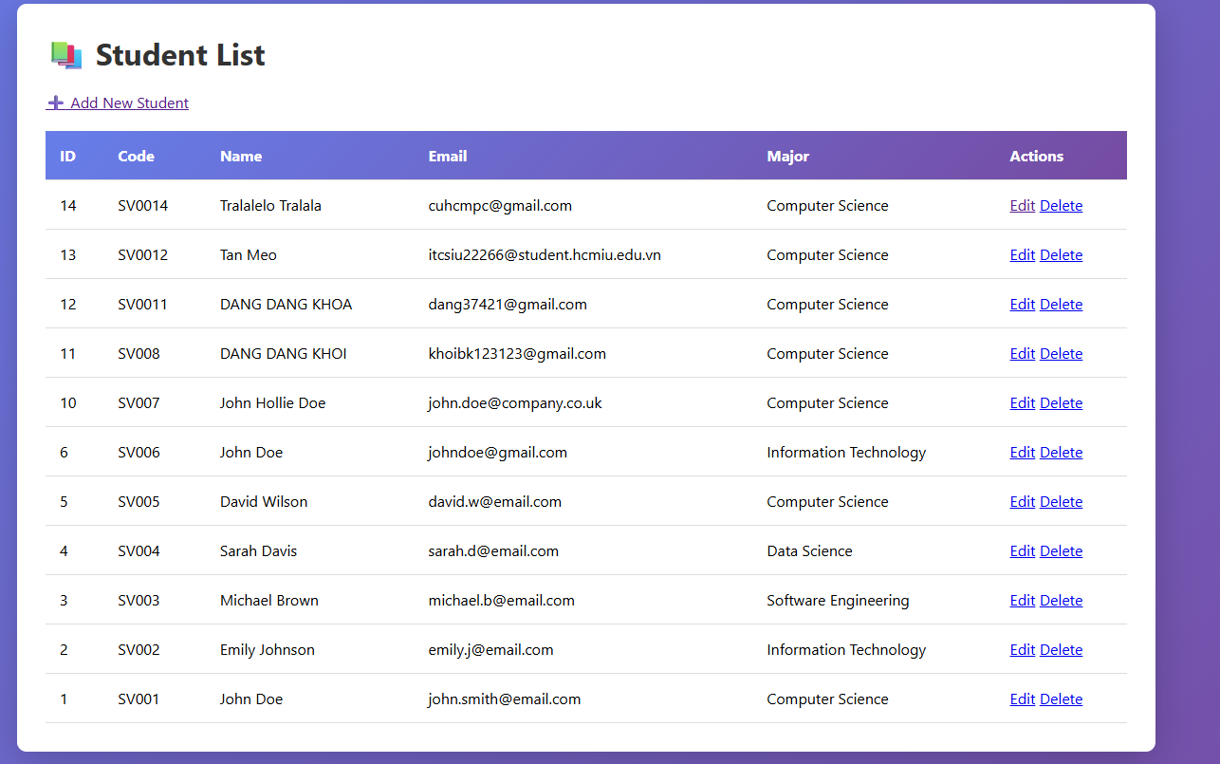
If login as user, wont have permission to edit or delete student.
If tried to access delete action through URL, will be blocked also
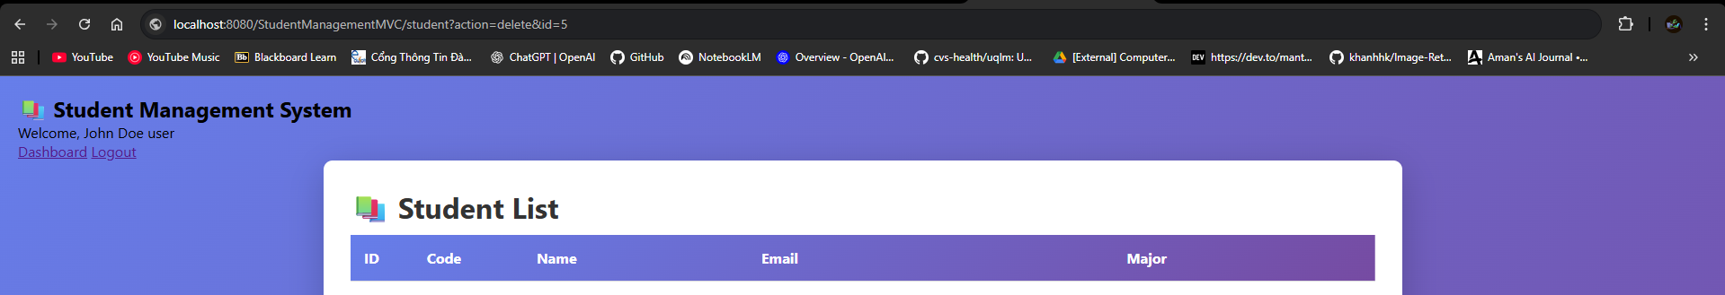
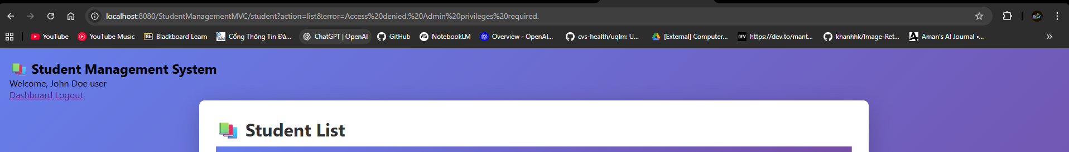
Exercise 7:
Admin has add new student function
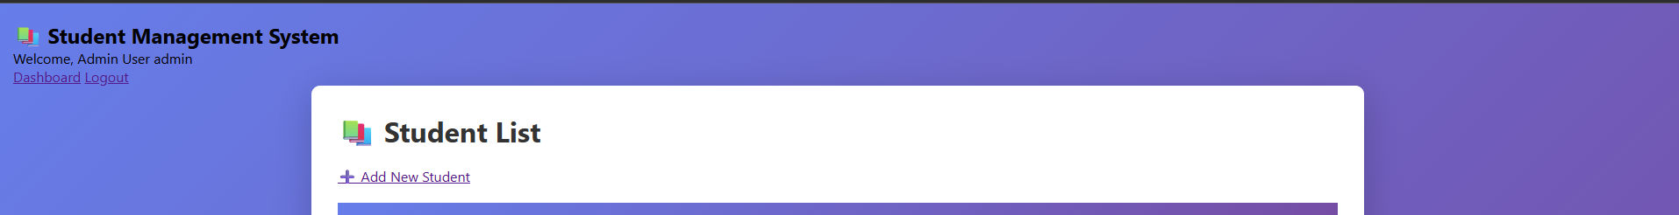while user don’t have permission to add student
Exercise 8:
Add change password button to change the password of the account
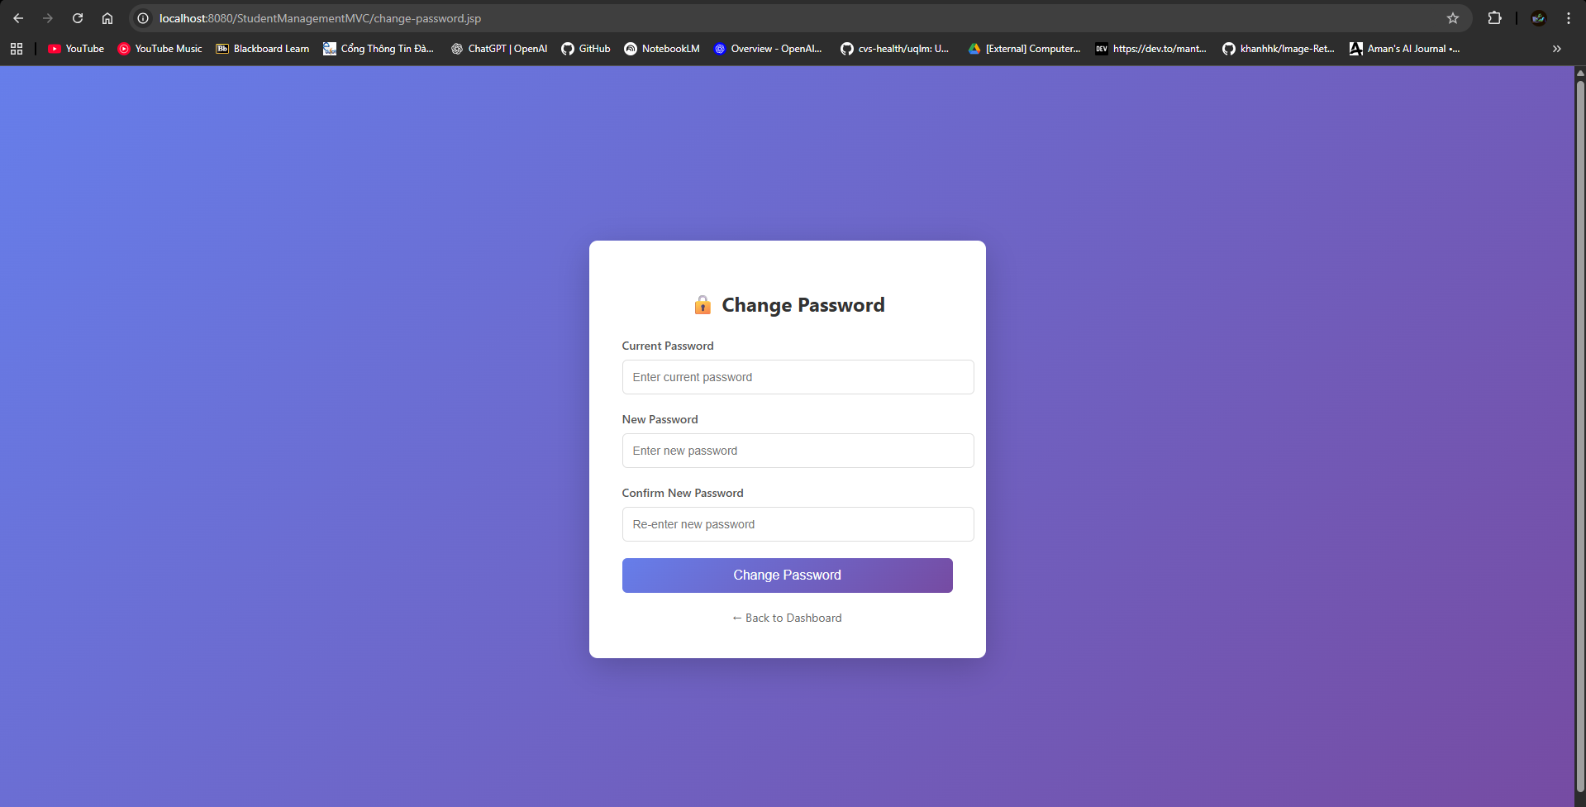
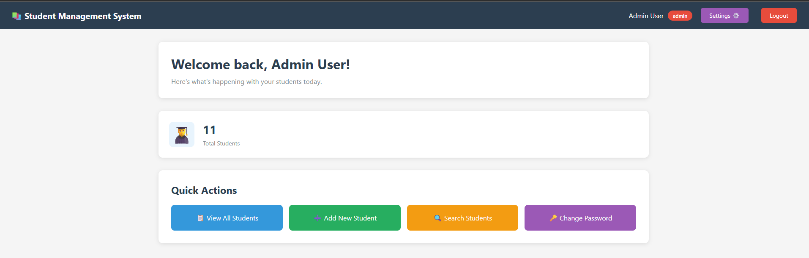
Full code explaination:
Access website, localhost:8080/StudentManagementMVC
AuthFilter.java get the cookie and session of the browser.
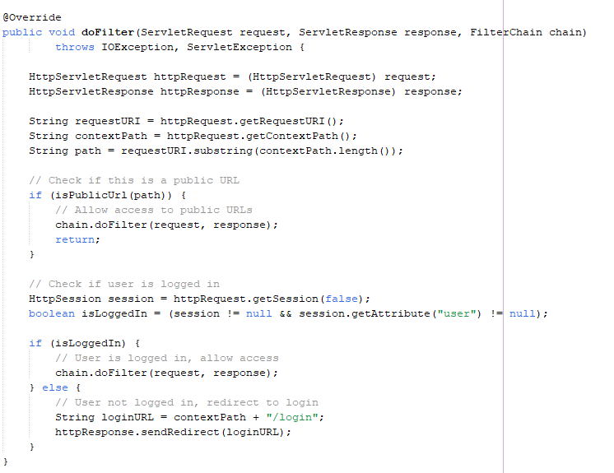
If user is logged in and the session still available, then grant access, else, navigate to login.
User login into the webpage with user name and password. Click remember me for faster login next time.
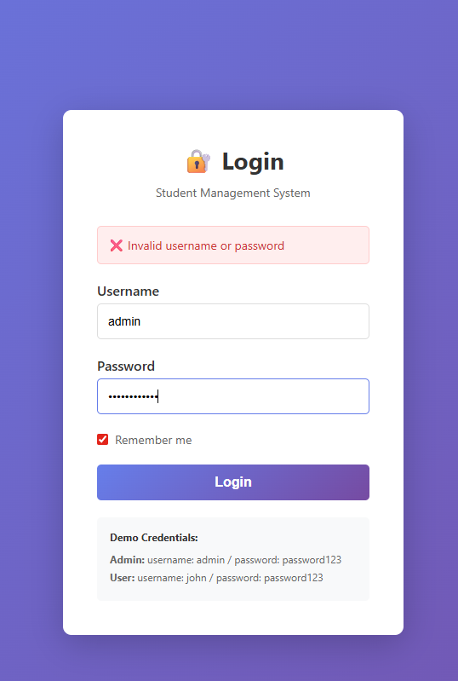
After login, check what is the user role, if admin, show admin dashboard.
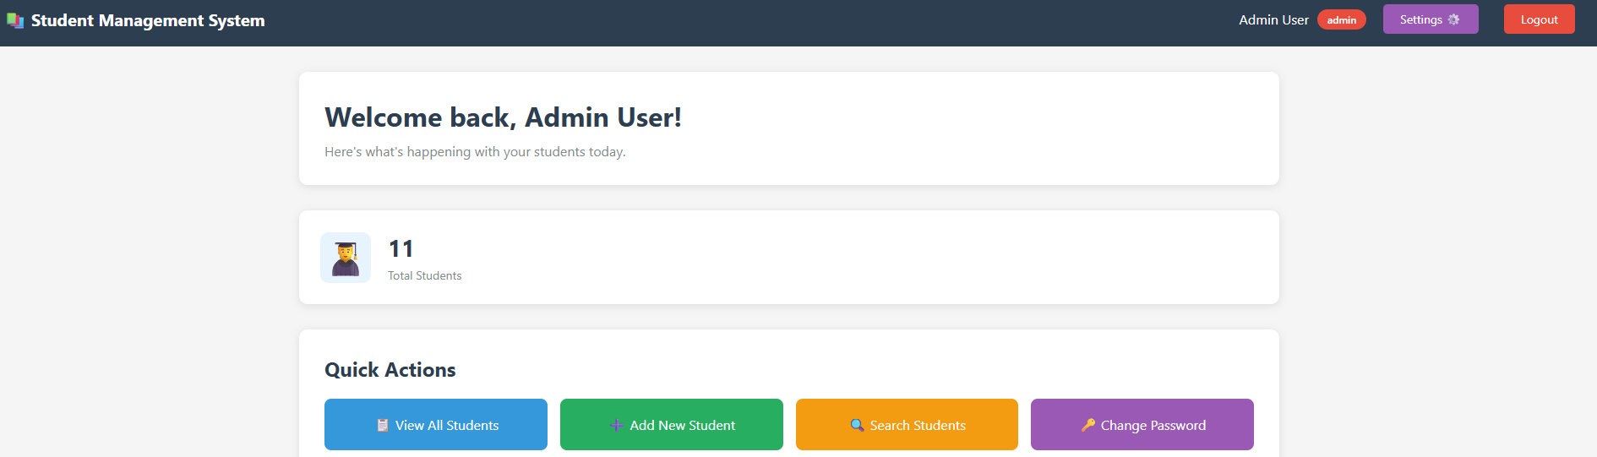
If user, show user dashboard
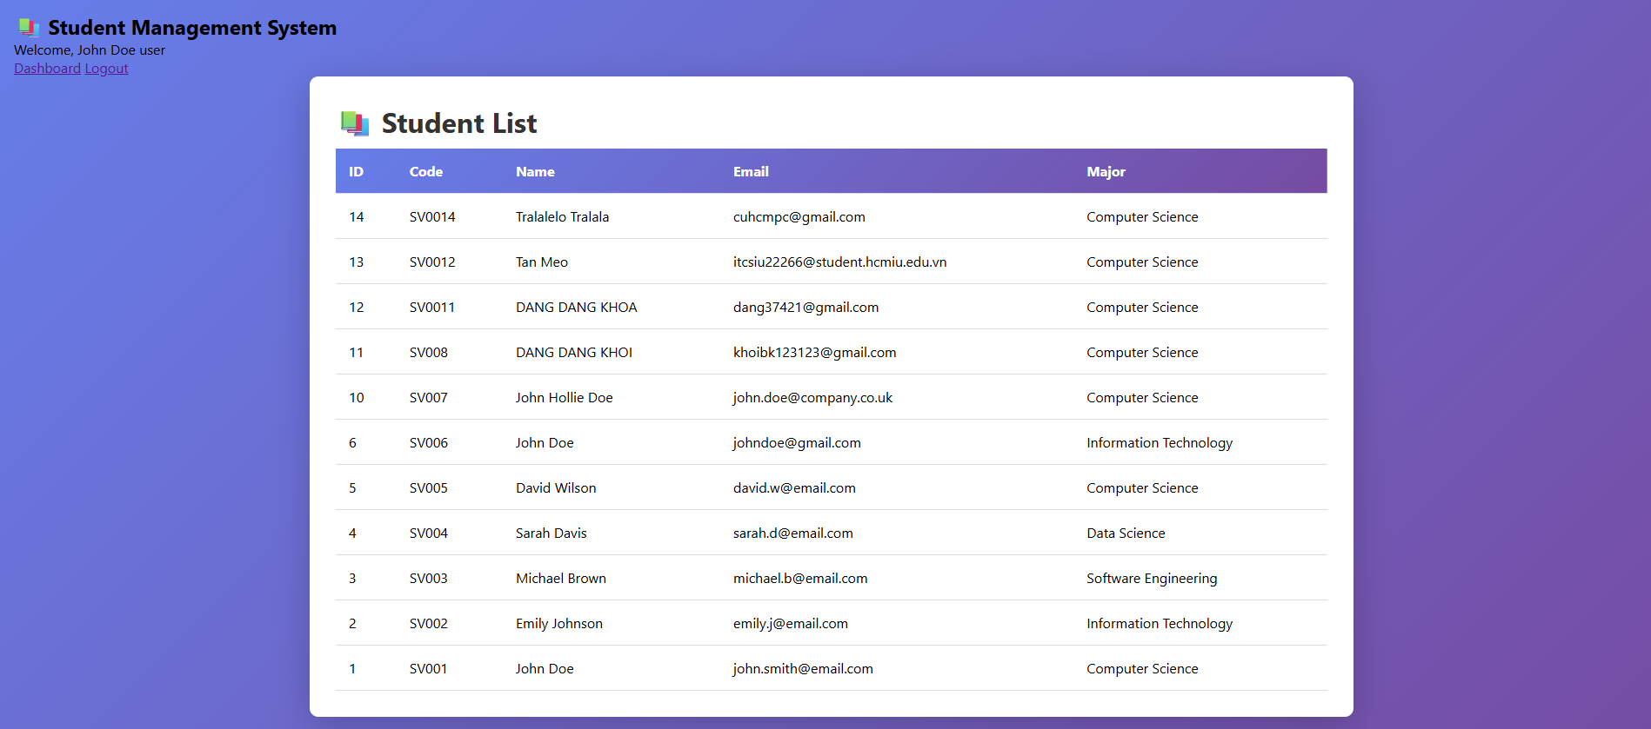
User don’t have permission to perform actions of admin role. This is blocked by AdminFilter.java
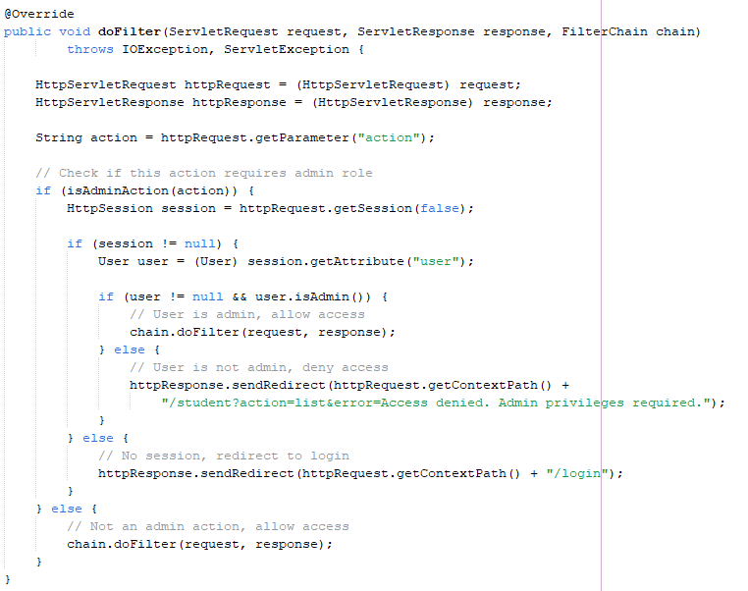
Admin can do many actions such as edit, add, delete students.
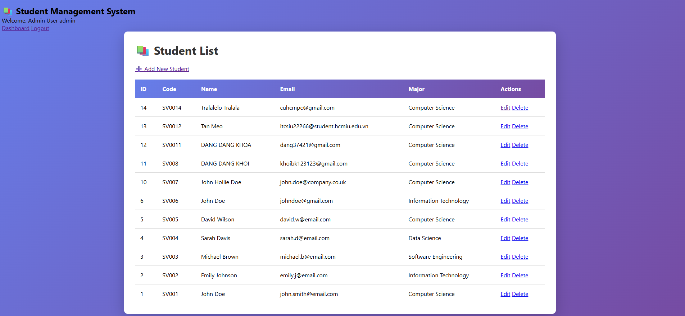
Both admin and user can change password 